Website Content

Sample Website

https://celerity.io/
https://acuity.co/tax-services/
https://www.littlefishaccounting.com/

https://pinnacleadvisorss.com/

Website Index

- Home Page

- Headline
  - Sub Headline
  - CTA Button

- Trusted by Clients

- Services Brief

- Our Approach

- Our Methodology

- Software Expertise

- Testimonials

- Subscribe to Our Insights /Blogs

- Book a Consultation CTA Button

- Services Detailed Page

- Global Entity Setup

- Heading
- Intro Para
- Embedded Youtube Video
- What we Provide
- Who this is for
- Related Content
- CTA – Book a Consultation

- Managed Accounting and Book Keeping
- Heading
- Intro Para
- What we provide
- How Do We Work
- Our Tiered Service Packages + CTA Button
- Our Sectoral Expertise
- Our Technology Advantage
- Video Embedded
- Related Content
- CTA Button

- Tax Compliance and Advisory
- Heading
- Intro
- Service Portfolio
  - Category-1 Individuals and HNIs
    - Services
  - Category-2 Business and Business Owners
    - Services
- Our Approach
- Related Content
- CTA Button

- Business Advisory
- Heading
- Intro
- What we provide
- Who Our Advisory Practice Is Built For
- Related Content/Case Studies
- CTA Button

- Support to CPAs and Accounting Firms
- Heading
- Intro
- HOW WE SUPPORT YOUR PRACTICE
- Approach and Differentiation Factor
- Who Do we work with
- Related Content/ Whitepapers
- Closing CTA

- About Us
- TLC Story
- Leadership Team
- Why True Ledger
- Data Security
- Key Figures and Statisitcs
- Our Young Team

Home

Headline
Option 1: Modern Accounting & Tax Solutions for Businesses Across the Globe
Sub-headline
We enhance your operations and efficiency through business intelligence, human judgment, and technology. (Also think of an alternative).

Imagery Suggestion- Globe Connecting Dots for various countries and Continents

CTA Button – Book a Consultation

Trusted by Multi-Jurisdictional Clients
From tech startups to hospitality groups, from FMCG giants to real estate firms - businesses across the US, Canada, Australia, and beyond trust TrueLedger to manage what matters most.
Make a carousel of clients with logo on the left and text on the right and the clients should change on the click.
- Michigan, USA An award-winning AI and data analytics firm serving Fortune 500 companies, with a strong footprint in the automotive industry across the US and India. TrueLedger manages their end-to-end accounting function - from bookkeeping and financial reporting to AP, AR, and payroll processing.

- New York, USA A dynamic multi-venue hospitality group operating in one of the world's most competitive restaurant and bar markets. TrueLedger handles their full financial operations - accounting, AP processing, entity formation, tax compliance, and management reporting.

- A Global Hospitality Chain founded in India, rapidly expanding footprint across the United States. TrueLedger supported US operations with payroll management and multi-state sales tax registrations across their property portfolio

- Canada A Canadian real estate investment group with a reputation built on results, operating across multiple business verticals. TrueLedger provides bookkeeping, payroll processing, and financial reporting to support their growing operations

- Melbourne, Australia An innovative Australian food and beverage company behind category-leading across 20,000 retail outlets nationally and exported across Asia. TrueLedger supports their accounts payable operations across their multi-location business

___________________________________________________________________________
SERVICES BRIEF FOR HOME PAGE

This should be stacked as Boxes and when we click the boxes brief description should pup up and the learn more button should appear( refer this website - https://www.bcg.com/)

Services Headline
How we Help clients
Every Great Business is built on the Right Financial Foundation.

- Global Entity Setup

We don't just file paperwork. We think about your structure before you sign anything. We guide founders and enterprises through every step of establishing a compliant, tax-efficient presence - whether you're setting up a US LLC or C-Corp, entering India, Canada, Singapore, or Australia, or structuring a multi-entity global footprint.
Image Suggestion: Image of a founder or a business entity (building) going big on ambition

Learn More Button

- Managed Accounting and Book -Keeping

Accurate books aren't just a deliverable - they're a discipline. Built on years of hands-on experience across industries and geographies. We manage your books on real- time : ensuring compliance, maintaining financial hygiene, and keeping you growth-ready every single day.

Imagery Suggestion

- A minimalist workspace with a notebook, laptop, and coffee - organised and approachable
- A clean financial dashboard on a laptop or tablet - real-time, modern, in control
- A professional reviewing documents with a calm, focused expression - discipline and precision

Learn More Button

- Tax Compliance and Planning
With deep expertise across global tax laws, cross-border structures and owner-level tax planning, we serve business owners in different jurisdictions and need an advisor who understands the full picture - entity and personal.

Imagery Suggestions
- A trusted advisor and client in a calm, focused conversation - relationship-driven
- A clean document or tax filing visual - professional and compliance-focused
- A glass-walled modern office meeting - advisory, strategic, high-trust

Learn More Button

- Advisory Services
Great businesses are built on great decisions and great decisions need the right advisor. Our advisory practice goes beyond numbers, working alongside founders and leadership teams on the things that shape a business long-term: strategy, governance, fundraising readiness, financial controls, and the technology infrastructure that holds it all together. When the stakes are high, we are the partner you want in the room.
Imagery Suggestion
  - A founder looking at a growth chart on a whiteboard - forward-looking and strategic
  - An overhead shot of a team around a table with laptops and printed reports - collaborative decision-making
  - A single professional at a window overlooking a city - vision, clarity, confidence
Learn More Button

- Support to CPAs and Accounting Firms

Every CPA firm reaches a point where the back-office work starts competing with the work that actually grows the business. That's where we come in. We become a natural extension of your team - handling client onboarding, day-to-day bookkeeping, month-end close, financial reporting, historical cleanups, payroll, and sales tax filings across your portfolio. When tax season peaks, we scale with you. When things are quieter, we keep the engine running. Your team stays focused on clients and growth - we take care of the rest.

Imagery Suggestion:
- A split-screen visual of two teams working in sync across different locations - conveying the offshore partnership feel
- A clean, modern desk setup with multiple screens showing dashboards and spreadsheets - professional and operational
- Two professionals in a relaxed but focused working session - human, collaborative, trustworthy

Learn More Button
______________________________________________________________
Our Approach (refer for formatting- https://www.littlefishaccounting.com/)
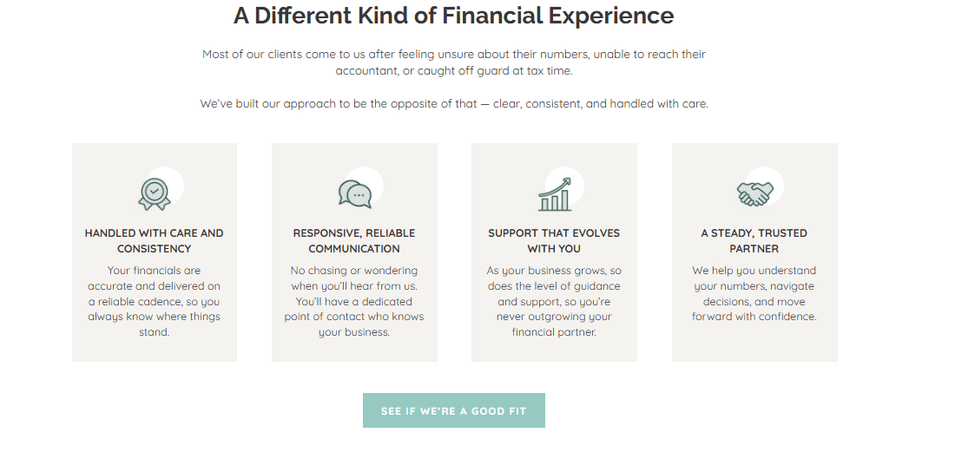
OUR APPROACH
THE ADVISOR YOU TRUST FROM DAY ONE
Great businesses aren't built on luck - they're built on the right guidance at the right time. We ask the right questions, and build a financial partnership rooted in trust, expertise, and a genuine stake in your long-term success.
- DEEP EXPERTISE, PERSONAL COMMITMENT We bring years of experience across global markets and complex business structures - applied personally to every client we work with. You get senior-level thinking, not junior execution.

- RESPONSIVE AND RELIABLE COMMUNICATION No chasing, no waiting, no surprises. You'll always have a dedicated point of contact who knows your business inside out and stays ahead of what it needs next.

- GROWS AS YOUR BUSINESS GROWS From startup to scale-up, from domestic to global - our advisory evolves with you. The more your business demands, the more we bring to the table.

- ACCURATE FINANCIALS. DELIVERED ON TIME. Your financials are only valuable if they're right and ready when you need them. We operate on disciplined timelines and rigorous review standards - so you always have numbers you can trust and make timely decisions.

___________________________________________________________________

Our Methodology
(Layout- TO be stacked with motion- https://www.youtube.com/shorts/JgXB4Mtw3R4)

- STRUCTURED ONBOARDING. SEAMLESS TRANSITION. A defined onboarding framework with pre-built checklists and clear timelines ensures a smooth transition -with value delivered from day one.

- TECH-POWERED WORKFLOWS FOR CONSISTENT DELIVERY. Tech-embedded workflows and rigorous review mechanisms ensure your books are closed accurately and on time - every single month, without exception.

- REAL-TIME VISIBILITY. INFORMED DECISIONS. Live dashboards give you continuous access to your financial position - so every decision is backed by current, reliable data.

- AUDIT-READY BOOKS. MAINTAINED YEAR-ROUND. Every transaction, reconciliation, and document is maintained to the highest standard - ensuring audit readiness at any point in the year, not just at year-end.

- TRANSPARENT PRICING . DEFINED SCOPE. Fixed monthly tier-based packages tailored to your need with a clearly defined scope - no hidden costs, no ambiguity, no surprises.

- GLOBAL TEAM. MULTI-TIMEZONE COVERAGE. An internationally distributed team ensures responsive, uninterrupted support wherever your business operates.

- INDUSTRY-SPECIFIC PROCESSES. PURPOSE-BUILT SOLUTIONS. Our frameworks, tools, and workflows are tailored to your industry delivering precision that a generic approach simply cannot.
____________________________________________________________________

Software Expertise(Grouped by Category)
Suggest some themes to present these software’s- We don’t like running script
- Cloud Ledger Software- QuickBooks/Xero/
- AI Native ERPs- Rillet/ Digits
- Bills and AP- Bill.com/ Dext/
- Payroll- Gusto/ADP
- Reporting- Reach Reporting/Floqast
- Tax Compliance and Planning- Drake/Holisti Plan
__________________________________________________________________
Client Reviews/Testimonials
As a carousel
_____________________________________________________________________
Subscribe to our Insights
Clean and Calm Image with a message- Clarity delivered to your mailbox

Subscribe button
____________________________________________________________________
Book a Consultation
Button at the bottom
____________________________________________________________________
Home PAGE Ends here

-------------------------------------------------------------------------------------------------------

Services – Detailed Section
Service #1 Global Entity Setup
We Don't Just File the Papers. We Help You Make the Right Call.
Setting up a business entity is rarely just a formality. The structure you choose, the state you register in, the agreements you put in place — these decisions shape how your business operates, gets taxed, and scales. Get them wrong early, and you spend years undoing it.
At TrueLedger, entity setup is a strategic exercise, not a checklist. Before filing a single document, we take time to understand your business model, growth plans, investor expectations, and cross-border needs — then guide you toward the structure that actually serves your goals.

Note-
- Across the section use stock images in background (blur) or in foreground
- Put what we cover(services) in animation or in Stacks and there should be right imagery across this section
________________________________________________________________________
Embed YouTube Explainer Video As well https://youtube.com/shorts/BkmOnZ4gbqw?si=AvzPjSWh-G96i-tt
______________________________________________________________________
What We Cover-

- ENTITY STRUCTURE CONSULTATION Not every business needs a C-Corp. Not every founder should default to an LLC. We walk you through the options — LLC, C-Corp, S-Corp, LLP, and more — explaining the implications of each, so you can make an informed decision rather than follow a template. The right structure should reflect your vision, your tax position, and where you want to take the business.

- STATE SELECTION STRATEGY Where you incorporate matters — it affects your tax exposure, compliance costs, investor readiness, and day-to-day operations. We help you evaluate the right state for your entity based on your business model, operational footprint, and long-term plans — whether that's Delaware, Wyoming, your home state, or somewhere else entirely.

- DRAFTING OF AGREEMENTS AND BYLAWS A well-run business is built on clarity from day one. We draft and review your core governing documents — operating agreements, bylaws, shareholder agreements — ensuring the rights, responsibilities, and expectations of all parties are clearly defined and protected before you open for business.

- REGULATORY FILINGS We manage all state and federal filings on your behalf — Articles of Incorporation, Articles of Organization, registered agent appointments, and associated compliance requirements — so your entity is set up correctly, compliant, and ready to operate from day one.

- VIRTUAL OFFICE SETUP No physical office? No problem. We help you establish a virtual office that gives your business a credible, professional address in your chosen state — satisfying regulatory and banking requirements without the cost of a dedicated space.

- TAX REGISTRATIONS
A registered entity is just the beginning. We ensure your business is fully equipped for tax compliance from the start — EIN registration, state payroll tax, sales tax across relevant jurisdictions — so nothing is overlooked and no obligations are missed.

- BANKING SETUP
Opening a business bank account — whether traditional or fintech — can be surprisingly complex for new entities, particularly for non-resident founders and international businesses. We guide you through the process, help you identify the right banking partner, and ensure your account is set up and operational so you can start transacting without delay.

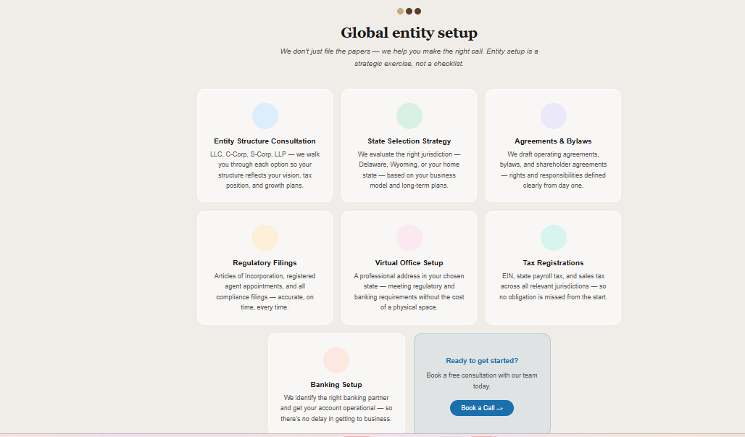
____________________________________________________________
Who This Is For
- International founders expanding into the US market
- US businesses establishing a presence in new states or countries
- Startups preparing for investment or cross-border operations
- Business owners who want their structure done right - not just done fast

In the end include Related Content Section – For latest resources related to this services- It can be in slow moving blog tickr(

Ready to get started? Let's have a conversation about what the right structure looks like for your business.

Service # 2 Managed Accounting and Bookkeeping

Unlock Scalable Growth with our Managed Accounting and Bookkeeping Solutions (Put in Quote Graphics or as a Section Header )
Growth demands financial clarity. Accurate books, timely reports, and disciplined compliance don't just keep you organized — they sharpen your decision-making, accelerate your momentum, and give you the confidence to scale. That is exactly what our managed accounting and bookkeeping service is built to deliver.
Note :
- Across the section use stock images in background (blur) or in foreground
- Put what we provide (Services) in animation or in Stacks and there should be right imagery across this section
What we provide

- REAL-TIME CLEAN BOOKS

We keep your books current, accurate, and properly categorized on an accrual basis - so your financials always reflect the true position of your business, in real time.

- ACCOUNTS RECEIVABLE, INVOICING & COLLECTIONS
From invoice creation to collections, we manage the full AR cycle — including revenue recognition schedules for SaaS and subscription businesses under ASC 606 — so your cash flow stays healthy and your recognized revenue remains compliant.
- ACCOUNTS PAYABLE MANAGEMENT & SPEND ADVISORY

We process vendor invoices, schedule payments, and monitor your spend patterns — so your outflows are organized and your cash position is always under control.

- PAYROLL PROCESSING
We handle payroll end to end — stock option and RSU reporting, multi-state compliance, benefits reconciliation — so every obligation is met and your team is paid accurately and on time.
- PERIODIC TAX FILINGS
We handle your sales tax and payroll tax filings on time, without chasing.
- FINANCIAL REPORTING
We deliver clean monthly financials — P&L, balance sheet, cash flow, and executive commentary — so leadership always has the clarity to make confident, well-informed decisions.

- Dashboards, Forecasts and Metrics Tracking
We go beyond monthly statements — delivering real-time dashboards, forward-looking cash flow forecasts, and KPI tracking frameworks tailored to your business model. Whether you're managing runway, monitoring margins, or preparing for a fundraise, you'll always have the financial clarity to move with confidence.
Put the above services in graphics like this way or better way

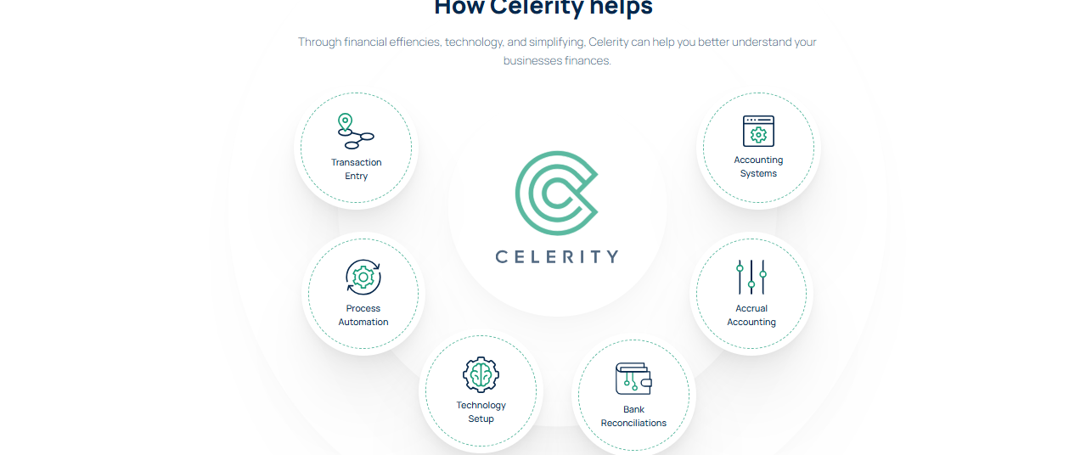

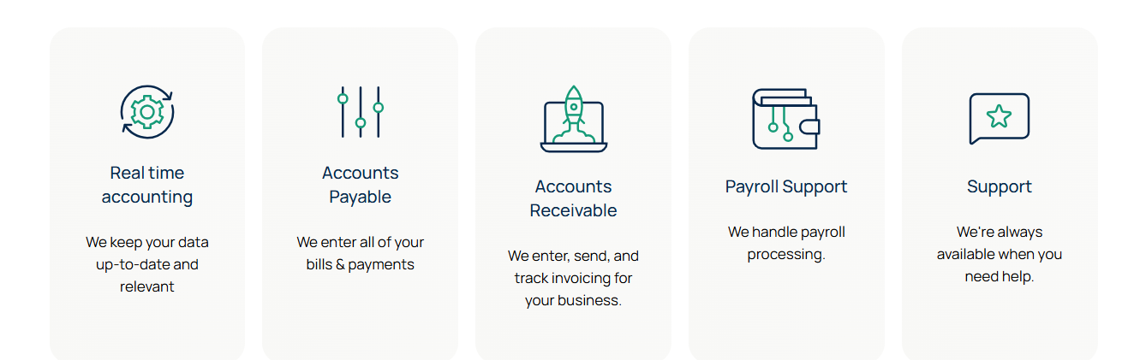

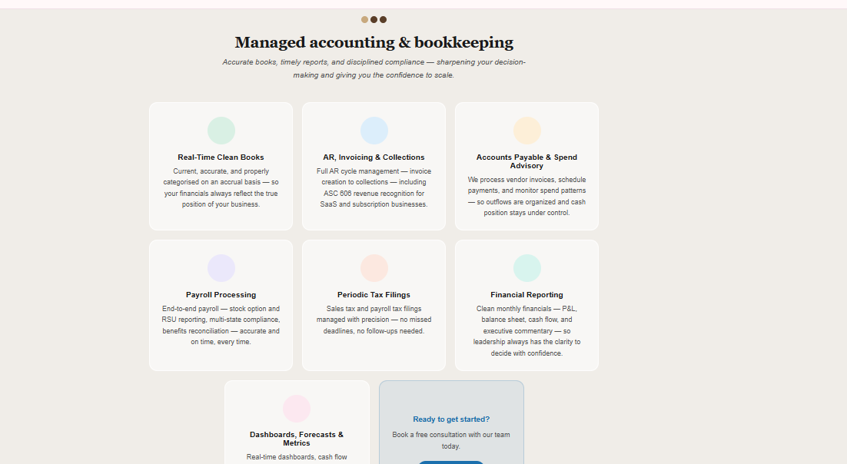
_________________________________________________________________________
How Do we Work??- (https://celerity.io/bookkeeping/, https://celerity.io/reporting/)

We specialize in managing the books for businesses and can ensure amazing communication and accuracy.
- Set-up your profile and connect your accounts
- Meet the team and start getting financial insights
- We start handling your bookkeeping
- We deliver monthly financial statements!
Use some infographics , process diagrams to cover the above text. For example
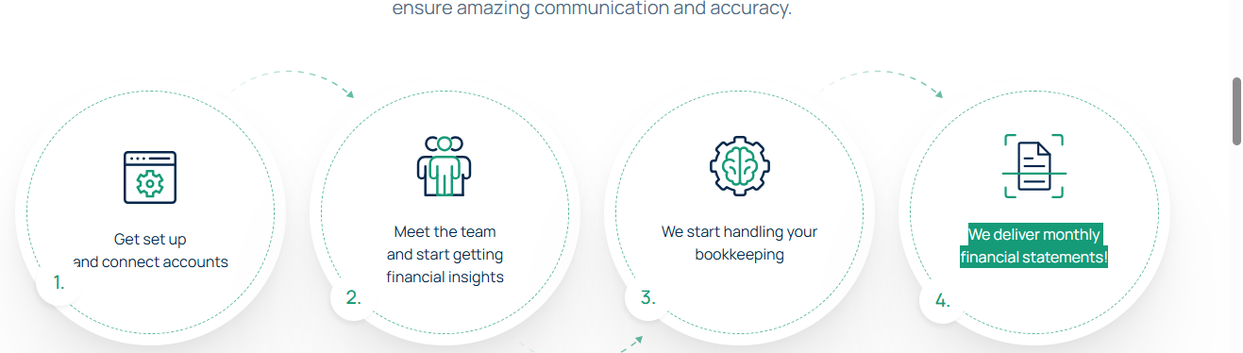
___________________________________________________________________
Our Tiered Service Packages
Reference

https://www.littlefishaccounting.com/services
https://futurefirm.co/tiered-pricing/
The Right Support, at Every Stage of Growth.
From clean books to full CFO partnership - find the plan that fits your business.

Essentials  Ranking – Low | Most popular · Growth  Ranking- Medium | CFO Partner  Rankin- Highest
Core Accounting | Full-Service Accounting | Strategic Finance
Clean, compliant books delivered on time every month. | End-to-end accounting with payroll, AP/AR, and tax filings managed for you. | A dedicated senior advisor who runs your finance function and helps you grow.
Starting at Custom pricing | Starting at  Custom pricing | Starting at  Custom pricing
What's included  - Accrual-based GAAP bookkeeping  - Bank & credit card reconciliations  - Transaction categorisation  - Monthly P&L, balance sheet & cash flow  - Cloud accounting software setup  - Quarterly financial review call  - Year-end closing & tax-ready financials  Check-ins Quarterly  Response time3 business days  Support- Email  Start Here | Everything in Essentials, plus  - Accounts payable & bill management  - Accounts receivable & invoicing  - Payroll processing (multi-state)  - Sales tax & payroll tax filings  - Monthly financials with executive commentary  - KPI tracking & variance analysis  - Monthly financial review call  - Spend advisory & AP controls  Check-ins :Monthly  Response time :2 business days  Support-Email & calls  See Clearly | Everything in Growth, plus  - Dedicated senior advisor / Virtual CFO  - Real-time financial dashboards  - Cash flow forecasting & modelling  - Annual budget & financial planning  - Proactive tax planning coordination  - Board & investor-ready reporting  - Strategic business advisory  - Bi-weekly CFO calls  - Priority access & unlimited support  Check-ins :Bi-weekly  Response time: Same / next day  Support: Unlimited  Plan Ahead

Don't See What You Need? Let's Build It Together.
Our custom tier is for businesses that don't fit a standard mould. Share your requirements and we'll put together a package that works exactly the way you do.

Book a Consultation Call
____________________________________________________________________
Our technology advantage
Software Expertise and certifications across multiple areas, illustrative tech stack
- Cloud Ledger Software- QuickBooks/Xero/
- AI Native ERPs- Rillet /Digits
- Bills and AP- Bill.com/ Dext/
- Payroll- Gusto/ADP/
- Reporting- Reach Reporting/Floqast
Present the above stack as pyramid (https://www.canva.com/design/DAG9uoOdtZE/t29zXO2xq7_SORhTMYj_tQ/edit)
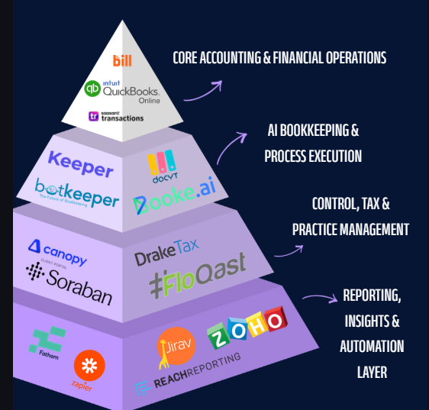
or some other way
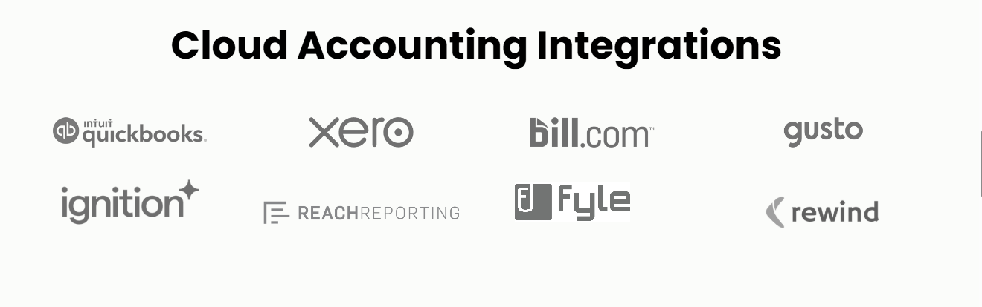__________________________________________________________
In the end include Related Content Section – For latest resources related to this services- It can be in slow moving blog tickr
Embed our Modern Finance Video- https://www.linkedin.com/feed/update/urn:li:activity:7454483598528909312
_________________________________________________________________________
CTA- Getting started is fast and easy!
Book a Discovery Call Now

Service # 3 Tax Compliance and Advisory
Reference - https://acuity.co/tax-services/

Tax Season Ends. Tax Planning Shouldn't.
Most people think about taxes once a year. We think about them all year round — and that difference is exactly what sets our services apart. Whether you are an individual navigating a complex financial life, a business owner managing multiple entities, or someone straddling two tax jurisdictions, we bring the expertise, the foresight, and the personal attention to get it right.
Note :
- Across the section use stock images in background (blur) or in foreground
- Put what we cover/services in animation or in Stacks and there should be right imagery across this section

Our Tax Services Portfolio

Category -1 For Individuals & High Net Worth Clients
We go beyond tax preparation. We help you make better financial decisions.(Should be in Quotes Graphics)
Managing personal taxes well means thinking beyond the return — understanding how your investments, business income, real estate, and long-term goals all connect. When personal and business tax planning happen under one roof, the strategies work in concert, and the outcomes are far greater than either could deliver alone.

- Individual Tax Return Preparation Accurate, complete, and filed on time — with a careful eye on every income source, deduction, and credit you are entitled to. No missed opportunities, no last-minute scrambles.

- Personal Tax Advisory — Quarterly & Year-End Tax planning is most effective when it happens throughout the year. We review your position quarterly, estimate your liability, and make adjustments before the year closes — so you are never caught off guard and never leave money on the table.

- Capital Gains & Real Estate Tax Planning The tax consequences of selling an investment, a property, or a business interest can be significant, but manageable with the right advice at the right time. We help you think through the timing, the structure, and the strategy before you act, not after.

- Retirement & Wealth Accumulation Planning The decisions you make today around retirement accounts, Roth conversions, and distributions have consequences that compound over decades. We help you build a tax-efficient retirement strategy that accounts for where you are now and where you want to be.

- Education, Charitable & Estate Planning Whether you are saving for a child's education, planning charity, or thinking about how your wealth passes to the next generation — we help you structure these decisions in a way that is both personally meaningful and tax-efficient. We work alongside your legal advisors to ensure your financial and estate plans are fully aligned.

- Cross-Border Tax Planning — NRIs & US Relocations Moving countries changes your tax life in ways most people underestimate — and the window to plan is often shorter than it appears. We specialize in advising individuals returning to India after years abroad, relocating to the US, or managing financial lives across both countries. Treaty benefits, foreign income reporting, FBAR obligations, and the RNOR window — we have been through these scenarios many times and know where the complexity lives.

Category-2 For Businesses & Business Owners
End your tax stress with expert business tax services. - Should be in Quotes Graphics
Taxes are complicated, and as your business grows, they’ll only get more difficult. Work with our tax experts to file on time and get the deductions and credits you deserve.
The best part? Our business tax service ensures that the tax planning strategies we implement for your business flow seamlessly into your personal tax return, maximizing your tax savings.

- Business Tax Return Preparation Thorough preparation and filing of federal and state returns across all entity types — C-Corps, S-Corps, partnerships, and LLCs. We coordinate your business and personal filings together, because the most important tax decisions sit at that intersection.

- Entity Structuring & Owner Compensation The right business structure and the right way to pay yourself can make a meaningful difference to your overall tax position. We advise on entity choice, restructuring opportunities, and the most efficient mix of salary, distributions, and benefits — taking the full picture into account, not just one side of it.

- Flow-Through Entity Planning For S-Corp and partnership owners, the relationship between business income and personal tax liability is rarely straightforward. We help you navigate basis tracking, qualified business income deductions, and K-1 positions — ensuring your structure works as efficiently as it should.

- Credits, Incentives & Capital Expenditure Planning R&D credits, energy incentives, Section 179 expensing, bonus depreciation — there are meaningful tax benefits that growing businesses frequently underutilize simply because they don't know they qualify. We identify what applies to your situation and make sure it is captured correctly.

- Multi-State Compliance & Quarterly Planning Expanding across states introduces tax obligations that often go unnoticed until they become a problem. We assess your exposure, manage your multi-state filings, and keep your estimated payments current throughout the year — so growth stays clean and tax season stays predictable
Present the services for Individuals and Business Owners separately in boxes or other info graphics
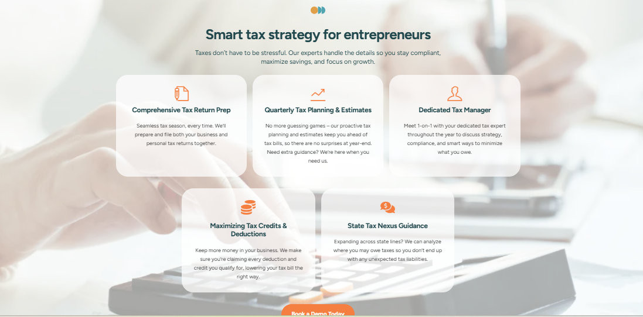

Our Approach
We build tax strategies that work for your specific situation - today and for the years ahead.
- Industry Expertise
We’ve worked with entrepreneurs across industries. Our deep expertise ensures tailored tax strategies that work for you.
- Year-Round Support
Our team is here year-round, not just tax season. Get advice to make smarter decisions and meet deadlines.
- Proactive Approach
By working with you throughout a year we anticipate tax charges before they happen and cover savings opportunity.
- Transparent Pricing
No hidden fees, no surprises—just clear, upfront pricing you can trust. Schedule of free consultation today for a custom quote
Present this in Timeline or stacked with right imagery

___________________________________________________________________
In the end include Related Content Section – For latest resources related to this services- It can be in slow moving blog tickr
__________________________________________________________________________
CTA- Getting started is fast and easy!
Book a Discovery Call Now

Service # 4 Business Advisory
The Right Advice, at the Right Time, Changes Everything.

Most businesses don't struggle because of a lack of effort. They struggle because the financial decisions — the structural ones, the strategic ones, the ones that compound over time — were made without the right advisor in the room.
At TrueLedger, our advisory practice is built for founders, business owners, and leadership teams who are serious about building something that lasts. We go well beyond compliance and reporting — bringing strategic thinking, operational expertise, and a genuine understanding of your business to every engagement.
What We Provide
- Strategic & Business Advisory
Where Your Numbers Meet Your Strategy.
Understanding your financials is one thing. Understanding what they mean for the future of your business is another. We work alongside leadership teams to model, stress-test, and validate the decisions that shape a business — before they are made, not after.
Our strategic advisory work includes :
- building robust financial models that reflect the true economics of your business,
- running scenario and sensitivity analyses to understand the impact of key decisions under different conditions, and
- developing valuation frameworks that give you a clear, defensible picture of what your business is worth — and what drives that value.
Whether you are evaluating a new market, structuring a partnership, preparing for a transaction, or simply trying to understand the financial logic behind your next move — we bring the analytical rigour and business judgment to help you move forward with clarity.

- Governance, Controls & Compliance Framework
Build the Foundation That Earns Trust.
Growth without structure creates risk. As your business scales — adding team members, taking on investors, entering new markets — the internal controls and governance frameworks that protect it need to scale too. We help businesses build those frameworks before they need them, not in response to a crisis.
What we help you build:
- Governance and Risk Management Framework - We design governance structures appropriate for your stage — defining decision rights, financial authorities, and oversight mechanisms that give your leadership team and stakeholders the confidence that the business is being run with discipline and accountability.

- Financial Controls Design From approval workflows and spend authorisation policies to segregation of duties and reconciliation procedures — we build the internal control environment that protects your business, reduces financial risk, and satisfies the expectations of auditors, lenders, and investors.

- Policy and Procedure Documentation - ormalising your financial policies is one of the most overlooked but highest-value investments a growing business can make. We document the policies that govern how your business manages money, reports results, and handles exceptions — giving your team clarity and giving your stakeholders confidence.

- SOC Certification Readiness- or technology businesses and service providers handling sensitive client data, SOC 1 and SOC 2 certification is increasingly a commercial requirement. We help you understand the gap between where your controls are today and where they need to be — and then we help you close it.

- Capital, Funding & Fundraising Readiness
Get Capital-Ready Before the Conversation Starts.
Raising capital — whether from venture investors, strategic partners, or public markets — is one of the most consequential things a business does. The quality of your financials, the clarity of your models, and the integrity of your documentation determine not just whether you raise, but at what terms and how quickly.
We prepare businesses for the full spectrum of capital events — ensuring that when the conversation starts, you are ready.
Fundraising Readiness We get your financials, models, and data rooms into the shape that sophisticated investors expect — clean historical books, well-structured projections, and supporting schedules that stand up to scrutiny. No scrambling, no last-minute cleanup.
Securities Listing & Public Market Advisory For businesses exploring a path to public markets, we provide advisory support across the listing process — including SPAC listings, direct listings, and US GAAP conversion projects for international businesses seeking access to US capital markets.
Audit & Due Diligence Readiness Due diligence is not the time to discover a problem. We conduct readiness reviews that identify gaps in your financial records, processes, and documentation — and address them before an investor or acquirer does.
Board & Investor Reporting Frameworks Sophisticated investors expect sophisticated reporting. We design the cadence, format, and content of your board and investor reporting — ensuring your stakeholders always have the financial clarity they need to stay engaged and supportive.
Historical Cleanup & Transaction Reconstruction Past transactions that were recorded incorrectly, periods that were never properly closed, or books that simply need a complete overhaul — we handle the cleanup work that creates a clean, reliable baseline to build from
- Finance Automation & Technology Advisory
The Right Tools, Properly Implemented, Transform a Finance Function.
Modern finance is not just about people and processes - it is about the technology infrastructure that connects them. The right tools, thoughtfully implemented, eliminate manual work, reduce errors, improve visibility, and free your team to focus on what actually creates value.
We advise on, design, and implement finance technology solutions for businesses at every stage — from early-stage startups building their first stack to scaling businesses that have outgrown their current tools.
- Finance Tech Stack Design We assess your current tools and workflows, identify the gaps, and recommend the right combination of platforms across accounting, payroll, AP, AR, expense management, and financial reporting. We are platform-agnostic and tool-experienced — our recommendations are driven by what is right for your business, not by any single vendor relationship.

- Workflow Automation Manual, repetitive finance processes are not just inefficient — they are a source of error and delay that compounds over time. We identify the highest-impact automation opportunities in your finance function and implement the integrations that eliminate them — freeing your team to focus on analysis and decision-making.

- System Migration & ERP Implementation When your business has outgrown its SMB accounting software and is ready to move to a more robust ERP environment, the migration needs to be handled carefully. We manage the transition — from data migration and chart of accounts restructuring to process redesign and team training — ensuring continuity and accuracy throughout.

- SOC-Compliant Technology Frameworks For businesses working toward SOC certification, the technology environment is a critical component of the audit scope. We help design and document the technology controls, access management protocols, and change management procedures that support a clean SOC audit.

Who Our Advisory Practice Is Built For
- Founders and leadership teams preparing for their next stage of growth
- Businesses approaching a capital raise, listing, or transaction
- Scaling companies that need governance and controls to match their ambition
- Operators who know their finance function needs upgrading but aren't sure where to start

Service #5 Support to CPAs and Accounting Firms
Every CPA Firm Reaches a Point Where It Needs More Hands. We Are Those Hands.
A dedicated offshore accounting team that plugs into your practice — qualified, process-driven, and built to scale with your firm through every season.

- HOW WE SUPPORT YOUR PRACTICE

Imagery: A clean, minimal desk with a laptop showing a tax dashboard and a calendar marked with deadlines — calm, organised, in control. Not stressed.

- Tax Season Support When the pressure peaks, we scale with you. We provide dedicated capacity during busy tax season — handling client bookkeeping, data preparation, and financial reporting so your team can focus on reviews, filings, and client communication without the crunch compromising quality.

- Accounting & Bookkeeping for Your Client Portfolio We manage the day-to-day and month-to-month accounting across your client portfolio — transactional entries, categorisation, reconciliations, and financial statement preparation — to the standards your firm sets and your clients expect.
- Month-End Close, Financial Reporting & Historical Cleanups Timely month-end closes, clean financial statements, and the historical cleanup and catch-up work that new client onboardings almost always require. We handle the heavy lifting so your team inherits clean, structured books — not a backlog.

- Sales Tax Filings & Payroll Processing Multi-state sales tax filings and payroll processing across your client base — managed accurately, filed on time, and fully documented. We handle the compliance volume so your firm does not have to.

- Approach and Differentiation Factor

There is no shortage of offshore accounting providers. What separates TrueLedger is the way we work — structured, transparent, and built to feel like an extension of your team rather than a vendor you have to manage.
Imagery: A simple side-by-side cost comparison graphic — onshore hire vs TrueLedger offshore engagement. Clean, professional, no gimmicks.

- Strategic Cost Advantage Extending your capacity through a dedicated offshore team significantly reduces your cost per engagement — without reducing quality. You deliver the same standard of work to your clients at a fraction of the cost of expanding your onshore headcount.

- Qualified Teams, Not Junior Resources Our teams are comprised of qualified accounting professionals — Chartered Accountants and experienced practitioners — not entry-level resources managed from a distance. You get professionals who understand accounting, not just data entry.
- Smoother Onboarding & Client Handling We bring structured onboarding frameworks and pre-built checklists to every new client engagement — so the transition is clean, the setup is fast, and your team is not spending weeks getting us up to speed.
- Dedicated Team With Full Practice Management Integration Your offshore team is dedicated to your firm — not shared across dozens of other clients. We work within your existing workflow and practice management tools including Karbon, Double, Aider, and others — so your processes stay intact and your visibility stays complete.
- Transparent Visibility on Hours & Work No black box. You have full visibility into your team's hours, task progress, and workflow status at all times — through the practice management tools you already use. Complete transparency, no surprises.
- Multi-Timezone Coverage With teams operating across the US, India, and other jurisdictions, we provide coverage across multiple time zones — ensuring work moves forward around the clock and deadlines are met regardless of geography.

- White paper
- Whitepaper 1 TrueLedger's Position for CPA Firms How a dedicated offshore partnership model works — and why it is different from traditional outsourcing.
CTA Button: Download the Whitepaper
Imagery: A clean, professional document preview — the whitepaper cover in TrueLedger's purple/pink brand palette.
- Whitepaper 2-CPA Firm Offshoring Readiness Assessment Checklist Before you offshore — know where your firm stands
- Imagery: A checklist-style graphic preview — clean, structured, actionable..
CTA Button: Download the Checklist

- WHO WE WORK WITH
A short line referencing the CPA firm support track record — number of client portfolios managed, jurisdictions covered, or a brief testimonial from a CPA firm partner if available.
Imagery: Clean logo placement or a quote card from a firm partner — professional, understated.

In the end include Related Content Section – For latest resources related to this services- It can be in slow moving blog tickr

- CLOSING CTA SECTION
LET'S FIND OUT IF WE ARE THE RIGHT FIT
Not Every Offshore Partner Is Built for Every Firm. Let's Make Sure We Are Right for Yours.
A quick call is all it takes. We will ask the right questions about your firm's workflow, client mix, and capacity needs — and give you an honest view of whether a TrueLedger partnership makes sense. No pressure, no generic pitch.
Primary CTA Button: Book a Consultation
Prefer to start with the readiness checklist? Download it above and come back when you are ready.

-------------------------------------------------------------------------------------------------------------------------

About Us

The TrueLedger Story

A 20-Minute Conversation That Changed Everything
Some of the best business ideas don't start in boardrooms - they start at airports, between flights, in the kind of honest conversation that only happens when two people have nowhere else to be.
That's exactly how TrueLedger Consulting was born.
Our founders (change the story to Manish and Aseem Sir- Mentor and Advisor/Board Member) had spent years working with global companies - navigating multi-jurisdictional compliance, tax controversy and disputes , managing cross-border accounting complexities, and building financial operations across some of the world's most demanding markets.
They believe that currently there is lack of true business partners, which businesses can rely upon not just for back office or operational work can be trusted as a true advisor having knowledge of multi jurisdiction accounting and tax regulatory frameworks

They had seen f what separated businesses that scaled smoothly from those that struggled: it was the quality of the expertise behind them. (To groom and use the quality talent and provide the services across the globe)
And yet, the market kept repeating the same mistake. Businesses were hiring accountants when what they really needed were expert financial professionals - people who understood business, not just books. - Manish to enter his GCC experience
That 20-minute conversation became a conviction: the world's talent shortage in accounting and finance is real, but so is the solution. India is home to a deep, highly qualified pool of finance professionals - CPAs, chartered accountants, tax specialists, and compliance experts - whose talent remains largely untapped by the businesses that need them most. The opportunity was clear. The timing was right. TrueLedger was born.

“Long-term partnerships, not transactions.
We measure our success by your growth. We don't chase volume - we build relationships. Our goal is to be the team you rely on as your business scales, not a vendor you replace every year. “
__________________________________________
OUR LEADERSHIP
Founders – pictures and experience
______________________________________________________________________

Why TrueLedger

- Senior professionals, proven across the world's best firms Our team brings decades of hands-on experience from Big 4 firms, MNCs, and GCCs — across the US, India, Canada, Singapore, and Australia. Every engagement is led and reviewed by senior professionals who have navigated complex, high-stakes work at the highest levels.

- Clients across geographies, industries, and complexities From tech startups in Silicon Valley and restaurants in New York, to NRIs managing cross-border wealth and CPA firms seeking US compliance support — we serve a diverse, global client base and understand what each one actually needs.

- Technology-first workflows, human-led advisory We use AI, automation, and modern accounting platforms to eliminate manual, repetitive work — so our professionals can focus entirely on what matters: critical review, sound judgment, and advice that protects and grows your business.

- A young, driven team with a client-first mindset No bureaucracy. No rigid hierarchies. Just a talented, energetic team that treats your business like their own — responsive, curious, and genuinely invested in your success.
____________________________________________________________________
Add About Security-( Refer https://www.littlefishaccounting.com/about)
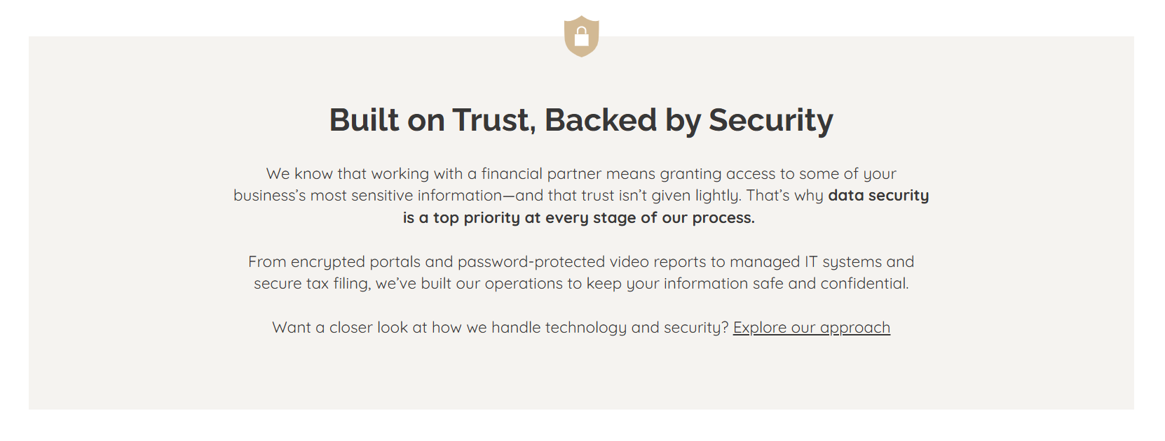
____________________________________________
KEY STATS AND CERTFICATIONS
Xxx clients
Xxx jurisdictions
Xxx number of business setups
Xxx software certifications
____________________________________________
OUR TEAM
Team Group Photos

03 - Who We Work With

Who We Work With

The World Is One Big Workplace - But Not Every Partner Is the Right Fit
Remote work and cloud technology have made global collaboration accessible to everyone. But accessibility doesn't mean fit. We are intentional about who we partner with, because the right match produces the best outcomes - for both sides.
TrueLedger is the right partner for: (Add details of sectors in the services page)
Established Mid-Size Businesses – Construction, Real Estate, Medical, Professional Services
High-Growth Startups - IT, AI, and SaaS, & more
E-Commerce and Retail
Restaurants and Supermarket Chains
CPA Firms
Format from Celerity Services Page or suggest something better
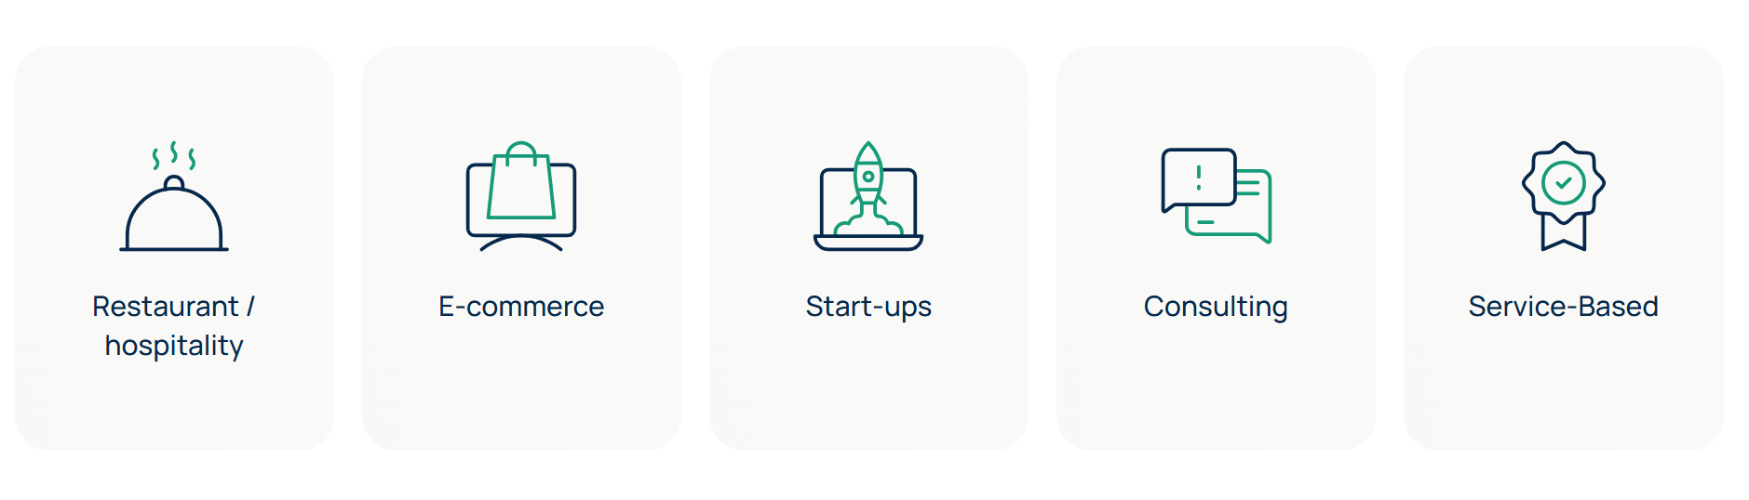

If your business is growing, expanding, or simply ready for a more capable financial partner - we should talk.
Beyond These Sectors
Our experience spans geographies and business models — and we're always open to working with businesses that align with our values. If you operate with ambition, take financial discipline seriously, and are looking for a partner rather than a vendor — we'd like to hear from you, regardless of the sector.
If you don't see your industry listed, reach out. With our extensive experience in the corporates, we’ve touched every corner of the industry.

Trust is not a claim. It is a track record. We are here to build one with you.

Ready to explore how TrueLedger can support your business?
connect@trueledgerconsulting.com | trueledgerconsulting.com

